Proposal for

India Seismographs in Schools Project

(ISeiS)

NOTE: This document was written by the authors below for a model project in India (we refer to the model project as ISeiS throughout) but it is intended to be reused and repurposed by others. We (Raspberry Shake, S.A.) hereby grant the user(s) of this document the ability to copy and repurpose this text under their own names without our permission.

Date: 14/01/2020
Authors:
Ian Nesbitt
Gabriel Low
Dr. Bernd Weber
Branden Christensen

For additional information: https://edu.raspberryshake.org/
Inquiries: sales@raspberryshake.org
Table of Contents
1 Summary 4
2 Introduction 4
3 Benefits of Raspberry Shake 5
4 Classroom Applications 7
4.1 Educational Goals 8
Earth and Physical Science 8
Computer Science 8
Community Engagement 9
4.2 Objectives 9
4.3 Example Use Cases 9
4.4 edu.raspberryshake.org 12
5 Broader Community and Scientific Impact 13
5.1 Target Group 13
5.2 Goals 13
Awareness 14
Science 14
Earthquake Early Warning 15
Disaster Response 15
5.3 Objectives 15
6 Technical Details 16
6.1 Raspberry Shake 16
6.2 Requirements 17
6.3 Worldwide Seismic Network 17
6.4 Regional Seismic Network Integration 17
6.5 Calibration for Ground Motion 17
6.6 System Compatibility 18
Platforms with an Internet Connection 18
Android Mobile Device or Tablet 18
Windows/Mac/Linux Computer with Java 18
For Advanced Students using Windows/Mac/Linux 18
7 Reference Projects 19
7.1 Seismology-at-School (Nepal) 19
7.2 AuSIS (Australia) 19
7.3 U.K. School Seismology Project (United Kingdom) 19
7.4 Sismos à l’École (France) 20
7.5 Seismo@School | SERA (European Union) 20
7.6 Princeton Earth Physics Project (USA) 21
7.7 Boston College Educational Seismology Project (USA) 21
7.8 Texas Educational Seismology Project (USA) 21
7.9 Rū (New Zealand) 21
7.10 Seismeolaíocht sa Scoil (Ireland) 21
7.11 StIRRRD (Seismographs in Schools Indonesia) 22
7.12 IRIS Seismographs in Schools (USA) 22
8 Implementation Considerations 22
8.1 Cost Estimation 23
9 Bibliography 26

Summary
Seismographs in Schools programs have proven to be successful and advantageous endeavors in scientific teaching at all levels of education, from grade school to university. Seismic school programs help teach a broad range of subjects, from physics to computer science. They allow students to contribute to global seismic monitoring efforts and engage with tangible scientific outcomes.
In this proposal, the Raspberry Shake (referred to variously as “Shake” and “RS”) will be highlighted as a powerful and accessible educational tool. The Raspberry Shake is a small, easy-to-use scientific-grade seismograph that costs less than most smartphones. It can be used in two main capacities:
- As an educational tool to teach scientific concepts in a classroom environment.
- As a professional-grade seismic station capable of densifying a pre-existing monitoring network.
Both of these capacities can be utilized simultaneously. Its dual-purpose nature, together with unrivaled low cost and extensive online resources, make the Raspberry Shake an excellent candidate to power a Seismographs in Schools Program.

Introduction
“India Seismographs in Schools” (ISeiS) is a multi-purpose educational seismic network project. It offers education and outreach opportunities, and provides seismic and infrasound data for research and monitoring.
Environmental sensors in classrooms are becoming increasingly popular in many levels of education, from elementary schools to universities. Weather stations, air-quality sensors, and seismographs have proven to be strong compliments to science and physics curricula. Environmental sensors can give students ways of engaging with science through hands-on learning and taking pride in contributing to broad scientific monitoring goals. Using live data, students can put to use concepts and skills they have learned during traditional lessons, as well as practice scientific communication skills with their communities.
Earthquakes are an almost globally-known phenomenon that few truly understand. Fear and mystery often surround the idea of earthquakes because of their destructive and unpredictable nature, and because the idea that the “solid earth” can move is disconcerting. The ISeiS project seeks to provide powerful teaching tools to educators, to increase public awareness of earthquakes and earthquake preparedness. This is done by educating students and adults about seismology and earth physics, and promote the sciences as potential future fields of study.
Learning about seismicity and seismology enables students and their communities to gain the knowledge that earthquakes are a fact of life that need to be respected, monitored, and prepared for. By participating in ISeiS, students will get a hands-on understanding of how earthquakes are recorded. They will become a part of the world’s largest seismic network, increase monitoring capabilities in their area, and become earthquake awareness advocates in their communities. Many Seismographs in Schools programs with similar goals have been implemented around the world (see Reference Projects in Section 7).
Similar to that outlined in Balfour et al. (2014), the ISeiS project aims to:
- Raise community awareness of earthquakes
- Raise awareness of seismology and geoscience, as fields of study
- Promote science as a possible career
- Provide tools to help teachers in teaching physical, earth, and computer sciences
The data schools collect are useful to researchers and will complement networks run by governments, universities, and supported data management centers. Data collected from the Raspberry Shake community network have provided clear recordings of both local and distant earthquakes. The project also involves an online education portal which allows students to access earthquake recordings in their own schools and around the world. A growing community of volunteers is forming to support the program within their local areas. Over the duration of the project these volunteers will enhance the project through provision of technical expertise as well as promotion within the education sector.

Benefits of Raspberry Shake
The Raspberry Shake is an easy-to-use, professional-grade seismic instrument that costs less than most smartphones. It is the perfect candidate for the ISeiS program, in both an educational and scientific sense. An image is shown in Figure 1.
Figure 1. A Raspberry Shake seismograph in a standard clear acrylic case. The brass cylinder frame on the left side of the case contains the geophone. The green board in the case is the Raspberry Pi computer, and the Raspberry Shake header board sits atop it. If the device contains accelerometers, they are contained in chips that are mounted atop the header board. Leveling feet and a bubble level on the case are used to adjust the device to the proper horizontal alignment. Waterproof cases are also available.
In an educational sense, Raspberry Shake is a powerful, engaging tool for students of all ages. For all students, having a Shake in the classroom is interactive and fun, and will stimulate an excitement for learning about science and their environment. Older students will be able to practice reading and understanding real-time data, and will benefit from enhanced excitement around earth, physical, and computer science concepts. Raspberry Shake gives students a way to more intuitively understand the world they live in. Additionally, since forwarded data is viewable live online, having a Shake at any given school provides the entire community with increased earthquake awareness and detection capabilities.
In a scientific sense, the Shake has a powerful impact. Each RS device is research-grade seismic equipment, and plays an important role in local and global earthquake detection. Every station can be connected to Raspberry Shake’s worldwide seismic network (Figure 2.), which facilitates a sense of participation in a larger citizen science community, and actively contributes to earthquake locations computed by the RS datacenter. Additionally, Shakes contain software that interfaces with many common seismic network protocols, and therefore, can be easily integrated into existing networks.
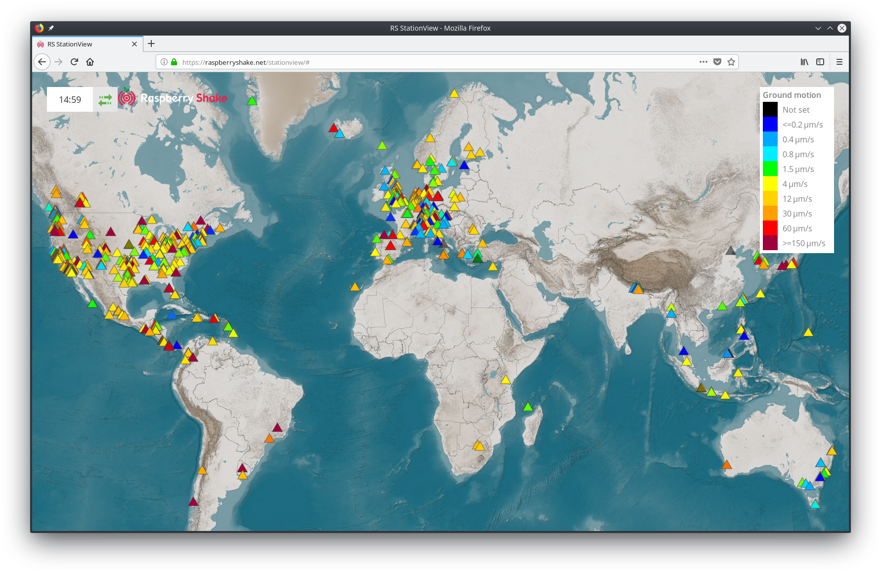
Figure 2. The Raspberry Shake worldwide seismic network. Online stations are represented by triangles and colored by ground motion in the last few minutes.

The RaspberryShake is extremely cost-effective. The Shake is a fraction of the price of comparable scientific-grade seismic stations, and features a much higher level of user-friendliness and educational applicability than comparably priced educational devices, making it unrivaled in its value. A comparison of popular educational seismic instruments is given in Table 1.
Table 1: Comparison of three popular educational seismic devices.
Device | Features | Cost (USD)
Raspberry Shake 1D | View live on worldwide seismic network, scientific-grade ground motion calibration, easily integrated into regional seismic networks, plug-and-play design, ethernet and WiFi-compatible | $375
Raspberry Shake 4D | All of the above, plus accelerometers which can record ground acceleration up to twice that of gravity (2g) | $500
Lego Seismometer | View live data from single unit, see apparatus move, ethernet and WiFi-compatible (via Raspberry Pi) | ~$100 (converted from GBP)
AS-1 / SEP | View live data from single unit, see apparatus move | $600 (discontinued, now build-your-own)
EQ-1 | View live data from single unit, see apparatus move | $700
TC-1 | View live data from single unit, see apparatus move | $430  (discontinued, now build-your-own)

The Shake is a tool simple and durable enough to use in hands-on classroom exercises, yet powerful and reliable enough to use as data sources for scientists and to fill in gaps in regional broadband seismic networks (Anthony et al., 2018). The ISeiS project can therefore serve the dual purpose of both teaching students and aiding scientists in seismic studies. This dual applicability, in conjunction with its low-cost, makes the Shake the ideal choice as ISeiS’s core teaching and monitoring instrument.

Classroom Applications
Having a seismograph in the classroom offers unparalleled opportunities for students to gain a real-world perspective of science in action; something that is not often afforded to them in traditional educational curricula. Many prior successful Seismographs in Schools projects have demonstrated that real-time seismology is an excellent way of enriching students' understanding of earth science, physics, mathematics, computer science, and science communication (see Reference Projects in Section 7).

Educational Goals
The ISeiS project seeks to educate students about Earth and Physical Science, Computer Science, and to encourage engagement with their communities to spread earthquake awareness and preparedness.

Earth and Physical Science
While physics and earth science concepts can be learned through a textbook, nothing compares to the direct demonstration of those concepts through real, scientific data collection and visualization. Raspberry Shake, its web apps, and its connected data visualization programs, provide explicit real-world opportunities to enhance understanding concepts such as:
- Plate tectonics and fault dynamics
- Wave properties (frequency, amplitude, period, propagation, attenuation)
- Seismic wave types
- Triangulation earthquake epicenters
- Non-earthquake seismicity
- Algorithms and earthquake magnitude, etc.
One of the many advantages of the Shake is that it is compatible with multiple free seismic data viewing platforms, including Swarm and JamaSeis, designed specifically towards teaching seismology and seismic data interpretation (see System Compatibility below).
- Swarm: Seismic wave analysis and real-time monitor, an application developed by the USGS to display and analyze seismic waveforms in real-time.
- JamaSeis: A program by IRIS that allows users to obtain and display seismic data in real-time from either a local instrument or from remote stations.
Programs like these can allow students to perform data processing tasks similar to what professional seismologists do on a daily basis.

Computer Science
The Shake is powered by Raspberry Pi, a small but powerful computer board that has become quite popular as an educational programming device. The Shake operating system is embedded in the Raspberry Pi. This makes it an easy platform to teach students basic computer communication concepts like IP addresses, Local Area Networks (LANs), and the wider internet as a whole. Furthermore, numerical processing and the theory behind measuring analog physical phenomena using digital signals.
The Shake also has UDP(User Datagram Protocol) data stream functionality, which sends raw seismic data in real time to a specified IP address over a local network. This means that the Shake is able to send raw data to multiple devices at once, and each device can therefore receive and process that data in different ways. This allows students to investigate seismic data in teams, and use either basic or intermediate programming languages to interact with and manipulate it.
Raspberry Shake has created a specific computer science curriculum using the educational programming language Node-Red to interact with UDP live data streams from its devices (see the edu.raspberryshake.org in Section 4.4). This allows students to practice using basic programming commands and concepts to process data and display visual output.
More advanced students can use tools in, among other things, the powerful scientific-friendly programming language Python (free), the statistical language R (free), or the scientifically-oriented MATLAB suite (paid license) to investigate, plot, and manipulate data. Numerous free visualization and processing tools are listed in the System Compatibility section below.

Community Engagement
More often than not, students are deprived of the sense that they are doing something important with their studies. Studies have shown that this can be incredibly detrimental to their willingness to learn. With ISeiS, students can engage with tangible, hands-on exercises, and ultimately feel proud of the important work they are doing to understand the world around them and to spread that knowledge to the community.
Not only does the Shake have the ability to help students make an impact by detecting earthquakes, it can also be used as a highly sensitive motion sensor that can be used as a trigger for a student-written code program. Tutorials of how to get started on this process can be found on Raspberry Shake’s educational site, edu.raspberryshake.org.

Objectives
Seismographs in the classroom will allow ISeiS to engage students in a way that will go beyond traditional learning and empower them to learn necessary skills to succeed. To meet the goals outlined above, the ISeiS project will:
- Help students learn to interpret and analyze real-world data
- Inspire pride in contributing to a worldwide scientific effort
- Teach students to become ambassadors who are able to spread earthquake awareness in their communities, and
- Encourage students to pursue STEM (science, technology, engineering, and math) career fields
Raspberry Shake has free educational resources, at edu.raspberryshake.org, to help educators achieve the goals outlined above.

Example Use Cases
Listed below are just a few of the many experiments and projects that are possible to do with the Raspberry Shake in Education. These types of hands-on projects are powerful for students to learn important technical skills and science concepts while participating in engaging activities and having fun. All of the activities and projects mentioned below have accompanying instructional resources and documentation that can be found at edu.raspberryshake.org.
- Shakemeter: The Shakemeter project combines coding, networking, and engineering skills to create a visual gauge that displays how much the ground is shaking in real-time (See photo below). This project incorporates multiple devices, networking principles, and programming languages throughout the building process. The tutorial for the Node-Red Shakemeter can be found at: https://edu.raspberryshake.org/classroom-curriculum/node-red/.
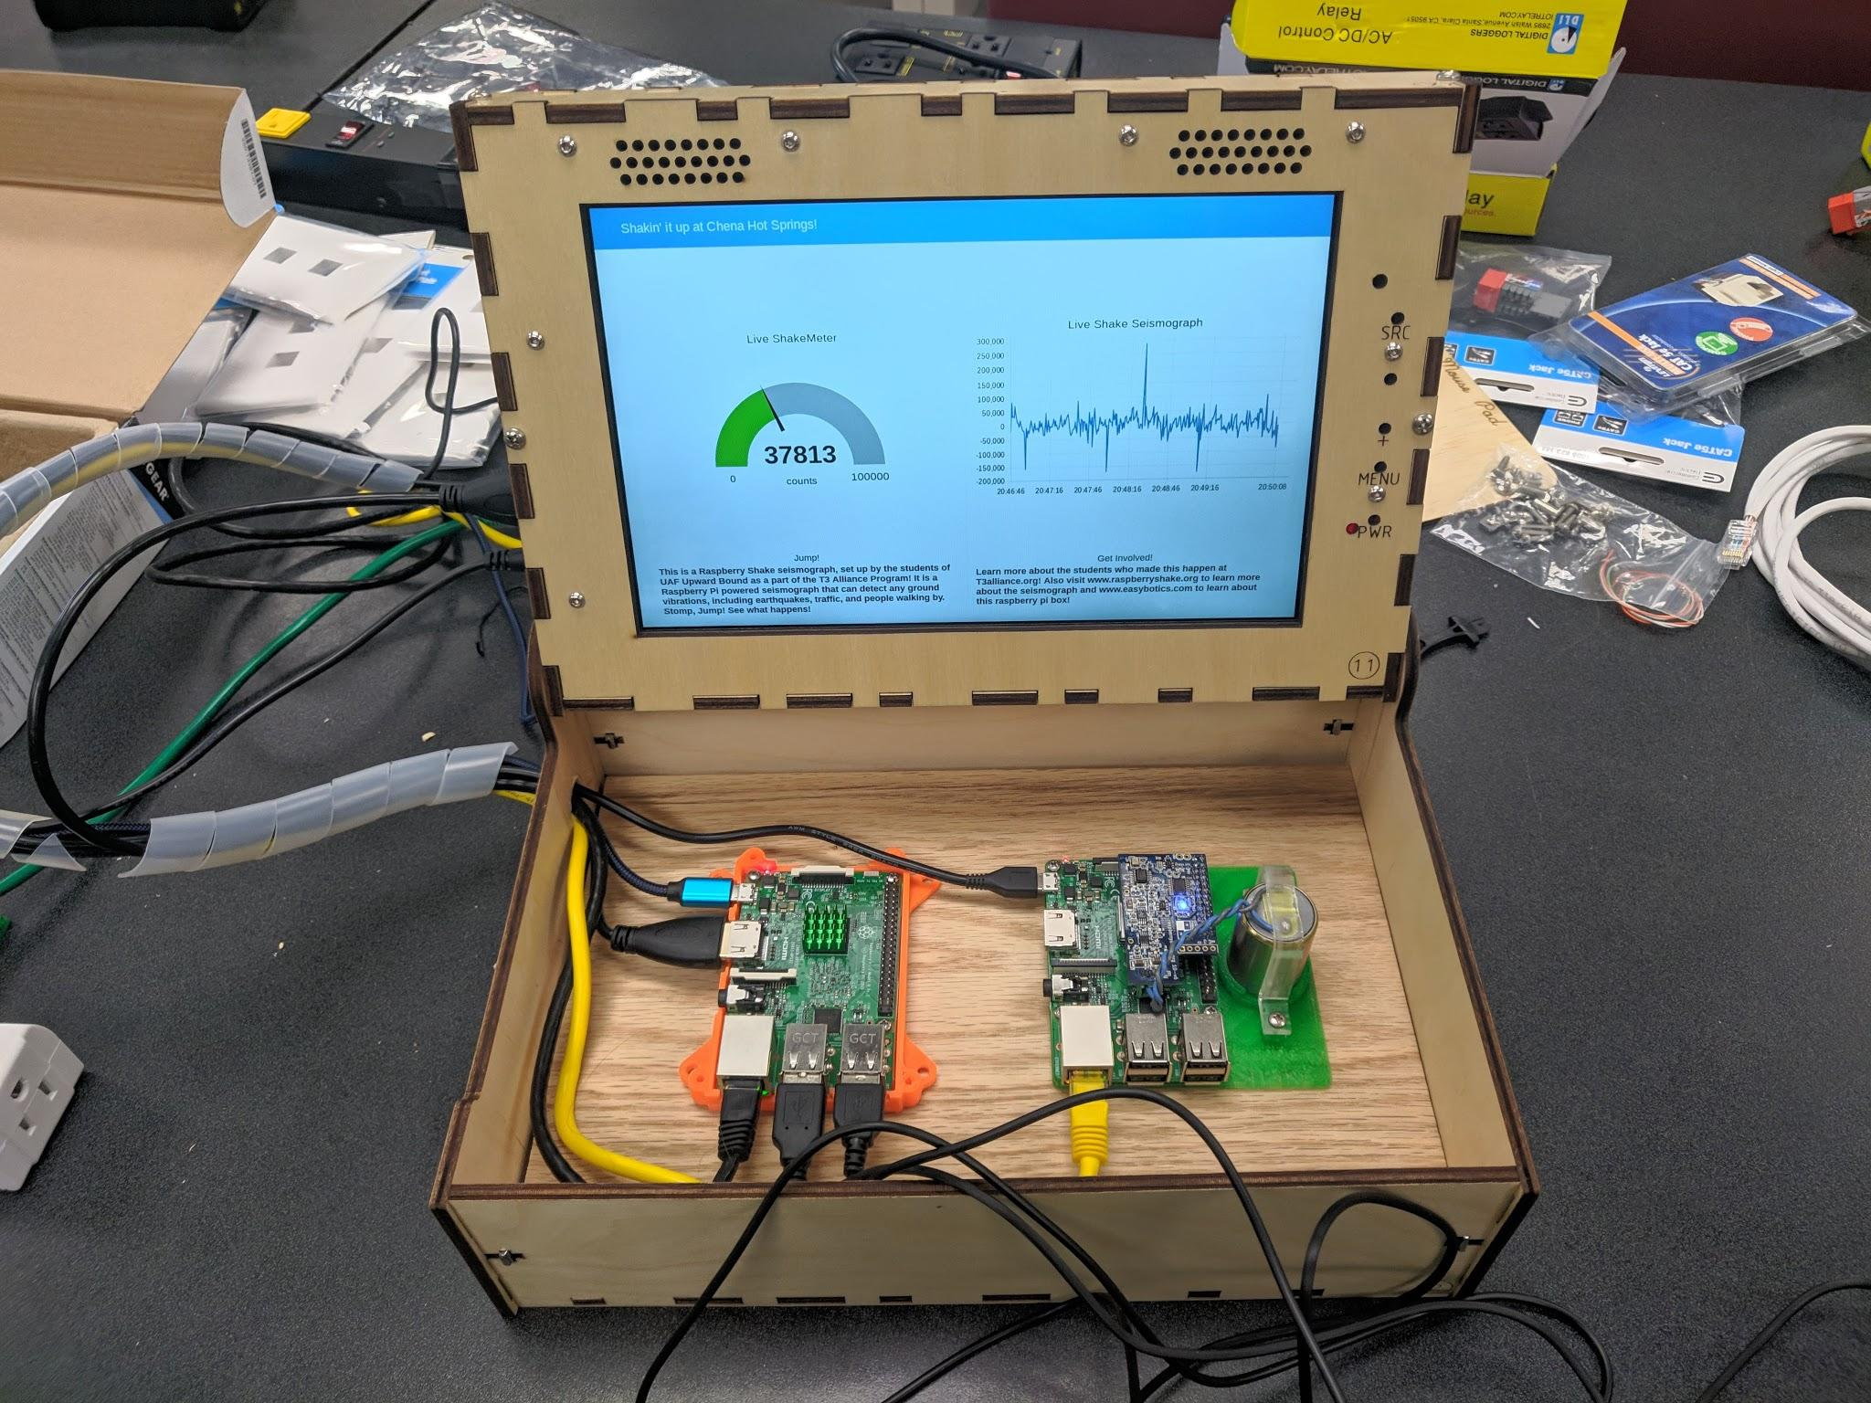
Figure 3. A Shakemeter station made by highschool students in Alaska. The Raspberry Shake is on the right (housed in a DIY 3d printed case) and there is a normal Raspberry Pi computer running Node-Red on the left, which is connected to the screen via HDMI.
- Energy Wave Experiment: In this experiment, students will understand how different mediums are better at transferring energy than others by observing how waveforms change depending on the material that the Raspberry Shake sensor sits upon. Scientists call this transfer of energy waves wave propagation. Concepts explored in this experiment can be connected to the real-world application of building and engineering in earthquake-prone areas. The lesson can be found at the link below: https://edu.raspberryshake.org/classroom-curriculum/wave-transfer-experiment/
- Traffic Light Earthquake Detector: This activity allows students to build a working earthquake alarm system. Students use the programming language Python and the Raspberry Pi GPIO wiring to make the alarm system. In order to set up the “Stop Light” alarm, students identify three different ranges of ground movement and correspond those ranges to green, yellow, and red lights. When ground movement increases, the light will change from green, to yellow, and finally red. The code can also be edited to emit an actual alarm sound through a speaker.
- Exploring Frequencies with Spectrograms: The incredibly sensitive geophone sensors that the Shake uses allows detection of even the smallest vibrations, and through data visualization software like Swarm, these frequencies can be analyzed. Naturally occurring events like volcanic activity, storms, or of course, earthquakes can be seen. However, it is much more common and accessible to see anthropogenic events (traffic, people moving, washing machines, etc.).
- Triangulating with EQ Locator: The EQ locator app is Raspberry Shake’s educational tool. It is built to allow users to step into the shoes of seismologists, go through finding earthquake epicenters using triangulation, and “pick” primary and secondary earthquake waveforms. The web app can be found on Raspberry Shake’s Website at https://locator.raspberryshake.net

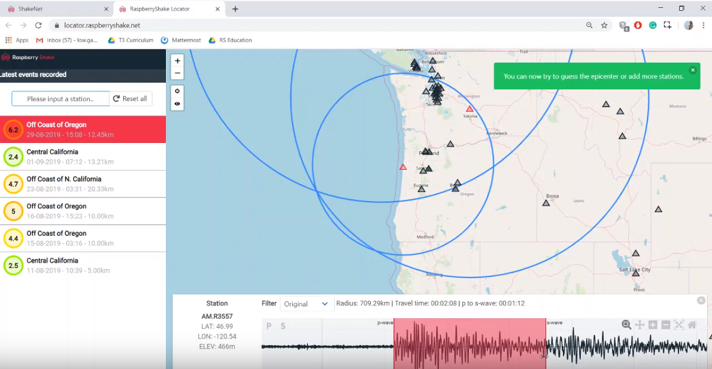
Figure 4. A screenshot of the EQ Locator app in use. Note the many stations available to pick from, the waveform from the selected station, and the red selection bars distinguishing the P and S waves. There is a step-by-step guide in the left corner for those starting out. The app can be accessed at locator.raspberryshake.net
- Node-Red Motion Alarm: The Node-Red motion alarm project, similar to the Shakemeter project, utilizes the Shake’s ability to forward live UDP data to another device. This is then programmed to interpret the ground motion data. In this specific activity, students use Node-Red to set a trigger value for the Shake’s ground motion readings. The action resulting from the trigger can be anything the students decide, including actions such as emitting noises, turning on lights, taking a photo/video, or even sending a text.
- Using Swarm to analyze data from Local Shake and Network: Swarm is a seismic data visualization software developed by the USGS for the purposes of education. It has many different functionalities including viewing waveforms, spectrograms, station maps, and more. Raspberry Shake provides the seismic data of its global seismic network (over 1000 stations) through Swarm. Students are able to access and analyze simultaneous data streams of ground motion data from stations around the world, and through this learn about global seismicity and wave propagation.

edu.raspberryshake.org
Raspberry Shake has a free, dedicated online resource database for educators. edu.raspberryshake.org has been developed by STEM educators for STEM educators, and contains everything teachers need to utilize the Raspberry Shake in a classroom environment. The extensive resource contains freely-available tutorials, lesson plans, video instruction, financial proposal resources, and more.

Figure 5. The Classroom Curriculum page of edu.raspberryshake.org. The open source, all inclusive educator resource has example lesson plans, tutorial videos, troubleshooting tips, classroom suggestions, and more.

Broader Community and Scientific Impact
Raspberry Shake has all of the functional monitoring capabilities of a high-grade seismograph in the 0.5 to 50 Hz frequency range (Anthony et al. 2018), which is the most commonly-used range in local (10s of km) and regional (100s of km) earthquake detection. Anthony et al. (2018) compared the Raspberry Shake 4D’s geophone and accelerometer to the Nanometrics Trillium Compact, the Nanometrics Titan, and the Kinemetrics EpiSensor (all devices that the USGS uses for aftershock studies) and found that the data recorded by Raspberry Shake are nearly identical to data from high-grade devices at the frequencies mentioned above. Anthony et al. (2018) conclude that Raspberry Shake devices are suitable for use in local and regional seismic monitoring networks. Raspberry Shake devices, and the worldwide seismic network:
- Can improve station density of existing seismic networks
- Data are free and publicly available via the RASPISHAKE datacenter after being recorded
- Increase emergency management agencies’ ability to respond effectively to disaster areas in the event of a destructive earthquake
Many of these features were previously only available on devices that cost several thousand or tens of thousands of dollars (USD). Because of the data density, accessibility of data, and the fact that the Shake has been verified as a viable alternative to much more expensive devices, academic seismologists are beginning to use data from Raspberry Shake installations maintained by citizen scientists in their research. The first published example of this is Hicks et al. (2019), who used data from a citizen’s Raspberry Shake as verification of earthquake events in a swarm in the southeastern United Kingdom.

Target Group
We anticipate Raspberry Shake will appeal to regional and local governments, universities, school administrators, teachers, and citizen scientists interested in earthquake safety and detection. We also believe that geophysical institutes will be interested in using ISeiS Raspberry Shake data to increase their network density.

Goals
Earthquake monitoring has long been the provenance of large universities and research institutions because of the cost of instruments required. For the same amount of money as a single broadband seismic instrument and seismic vault installation, a school system can purchase 200 Raspberry Shake 1D devices. This would go a lot further towards monitoring local earthquakes and understanding local seismic hazard than the single broadband. The community and scientific objectives of the Seismographs in Schools project are:
- Awareness: Increase community awareness of earthquake safety and local monitoring efforts
- Science: Help scientists improve regional seismic velocity and earthquake risk models
- Earthquake Early Warning (EEW): Work towards creating a seismic network dense enough to facilitate life-saving Earthquake Early Warning technology using Raspberry Shake educational seismographs
- Disaster Response: Help provide ground motion data to aid disaster response resource allocation in the event of a damaging earthquake
We expand on these goals in the sections below.

Awareness
Raspberry Shake devices make earthquake monitoring accessible to schools and communities who otherwise would not have the ability to obtain even one seismic monitoring instrument. The accessibility of data from Shakes make viewing and sharing seismic data among students, parents, and community members a fun and community-building process. It also can be paired with earthquake safety messages such as “DROP, COVER, and HOLD ON” to increase awareness of personal earthquake safety measures among community members.
Seismology in Schools is an ideal way for students to become active in promoting earthquake awareness in their communities. Teaching is often the best way to learn a subject. Student ambassadors can learn about earthquakes through the program, then teach their friends and families in turn. They will come to understand complex and useful earth and computer science concepts in the process.
Because Raspberry Shakes are so affordable, they also offer citizen scientists the opportunity to engage in seismology. Seismology is a field formerly only reserved for amateur or professional seismologists. Amateur seismologists were either capable of building a seismograph, wealthy enough to purchase one, or lucky enough to inherit one. Citizen science is extremely important for making and reporting on-the-ground observations, which academic science often lacks, and for communicating awareness of and trust in science as a concept. Citizen science bridges a formidable gap between lay people and scientists, and helps fill a much needed role of extracurricular and extra-academic education. The hands-on nature of Raspberry Shake makes it a perfect tool for both structured education inside the classroom and self-directed education outside.

Science
One major obstacle in seismic hazard assessment is the lack of knowledge of how local bedrock and ground material conducts earthquake waves. Seismology holds the key to creating seismic velocity and ground shaking amplification models. These can highlight hazards and determine areas necessary to spread awareness of life-saving earthquake preparation procedures. This is important in every earthquake-prone area, but especially those that have high earthquake risk but low seismic station density. Seismic networks presently do not have near the station density required to accurately calculate seismic and liquefaction hazard or earthquake wave travel times in most parts of the world.
Most seismic velocity or wave amplification studies require two things: dense regional network coverage and observation time. Raspberry Shake devices are ideal for these types of study due to their cost-effective nature and their durability. Additionally, their ability to set their internal clock very accurately using either the internet or a compatible global positioning system (GPS) device. Shakes have the ability to time earthquake wave arrivals to within 10 ms, comparable to the most commonly used seismic instruments, which can aid in the creation of velocity and amplification maps and models. This is especially necessary in and around populated areas, which are often seismically vulnerable but not often chosen for seismic studies due to the relative abundance of anthropogenic noise.
Modern earthquake detection can overcome the problem of having many stations located close to sources of noise like footsteps, automobile and rail routes, and construction sites. The more dense the network, the better detection systems are able to differentiate between signal and noise. As a citizen science project, the RS network will naturally tend to become densest in cities. This is a unique opportunity for the field of seismology to advance knowledge of how many of the world’s populated areas must adapt to the dangers posed by nearby seismicity. ISeiS can contribute to life-saving discoveries about earthquake-prone areas and advance the cutting-edge in the field of seismology.

Earthquake Early Warning
While earthquakes can never be predicted ahead of time, dense networks of devices can be used as a way to warn and protect people a few seconds in advance of damaging and life-threatening earthquake shaking. This is called Earthquake Early Warning (EEW). The more stations there are in earthquake-prone areas, the better chance EEW has of being able to work effectively to provide a few potentially life-saving seconds of advance notice prior to strong shaking. Raspberry Shake is able to send data packets quickly and regularly and can therefore be used in EEW networks.

Disaster Response
In the event of a destructive earthquake, seismic networks are critical to providing emergency management agencies with the data they need to make time-sensitive resource allocation decisions in order to save lives. Even the most basic RS instruments can be used to give first responders an idea of conditions on the ground at the time of the quake, especially in areas that have little or no prior seismic network coverage. The RS4D includes “strong motion” accelerometer sensors and can be bolted to the floor to provide detailed ground motion data up to twice the force of gravity (2g). This can help disaster response units determine if buildings in the area are likely to have collapsed during a damaging quake. Additionally, since Shakes use very little power, they can last for several hours powered only by battery backup devices(sold separately).

Objectives
The cost-effectiveness of Raspberry Shake brings these goals within more achievable reach than many previous projects. These projects have either used more expensive equipment, and thus were cost-prohibitive, or used equipment that could not provide data to satisfy the scientific goals. Raspberry Shake improves on past projects by providing the best of both worlds. We propose to satisfy the scientific goals by:
- Giving teachers and administrators the tools and support they need to maintain ISeiS devices
- Densifying currently-active seismic networks through the ISeiS program by placing seismometers in schools located in and around areas known to be prone to seismicity
- Spreading earthquake safety information via ISeiS student ambassadors and official resources
- Providing university laboratories with funding to utilize ISeiS seismic data to improve modeling and analysis of earthquakes and earthquake-prone areas

Technical Details
Technical details of the Raspberry Shake are available in the project’s online manual at https://manual.raspberryshake.org/. They are discussed further below.

Raspberry Shake
Raspberry Shake is powered by Raspberry Pi, a credit card-sized personal computer that runs a variant of the Debian Linux operating system. Raspberry Shake has created a digitizer in the form of a header board which fits on top of the Pi, and includes one to two types of motion-sensitive instruments, geophones and accelerometers. An image of Raspberry Shake is shown in Fig. 1.
The first type of instrument, called a geophone, is what seismologists call a “weak motion” sensor. The geophone consists of a weighted “mass,” an electromagnet suspended on a spring inside a durable metal tube called a “frame.” The mass is free to move on only one axis inside the frame. In the words of Latham et al. (1971), who were describing a seismic experiment on the moon but which also applies to Raspberry Shakes, “The suspended mass tends to remain fixed in space because of its own inertia while the frame moves around the mass. The resulting relative motion between the mass and the frame can be recorded and used to calculate [the] original ground motion...” The process of the frame moving around the geophone mass generates an electromagnetic current which is then recorded by the digitizer board and the software inside the Shake.
The second type of instrument, an accelerometer, is commonly used today in nearly every smartphone device. Accelerometers are “strong motion” sensors, which are tiny microchips designed to create an electric current proportional to acceleration. The accelerometers used by Raspberry Shake are designed to ignore most of the “weak motion” which is the job of the geophone, but capture essentially every earth movement humans are able to feel, all the way up to twice the acceleration of gravity. In other words, RS4D devices are able to faithfully record every movement from the hundred-nanometer scale (0.0000001 meters) to the ten-meter scale per second. The electromagnetic current generated by geophone and the accelerometers are each recorded by the digitizer 100 times per second.
Time can be kept using either the internet (via the network timing protocol NTP) or with an optional GPS device. The Raspberry Shake encodes all of its data with industry-standard seismological timekeeping units of Universal Time Coordinated (UTC) and outputs universally readable MiniSEED files, also an industry standard.

Requirements
At its simplest operational level, the Raspberry Shake requires just power and internet. Its design lends itself to either a plug-and-play solution or a relatively simple yet informative do-it-yourself project for students. The fully-assembled plug-and-play device requires:
- 5 volts and 2.5 amps of electrical power, delivered via Micro USB
- To share data from a single RS1D, an internet connection capable of at least 0.0015 MB/s upload speed (0.012 Mbps) which is easily achieved with most default internet plans available in the first and developing worlds
  - Ethernet (hard-wired) is preferable because it is far more reliable than WiFi (wireless)
- If the device will share data with the worldwide network, an email address for notifications when the device goes offline
- Someone to speak with Raspberry Shake Support personnel in the event of technical problems

Worldwide Seismic Network
Raspberry Shake’s large and rapidly-growing worldwide seismic network has about 1000 online units (Fig. 2). The RS network can provide accurate earthquake detection faster than many state-sponsored seismic networks including the United States Geological Survey (USGS) and the European-Mediterranean Seismological Centre (EMSC). The only requirements to connect a Shake to the network are an internet connection and an email address for offline notifications.

Regional Seismic Network Integration
Raspberry Shake devices are designed to be easily integrated into any modern seismic network. Each station supports connections via both Wave Server (FDSN and Earthworm) and Seedlink, the most commonly used data transmission protocols in seismic monitoring. These protocols can be used simultaneously for school kiosk displays and as portals for geophysical institutes to retrieve data.

Calibration for Ground Motion
The geophones and accelerometers inside the Shake are calibrated in order to record extremely exact measurements of ground motion. Each device records ground motion in “counts,” a measurement of electric current that represents the velocity of the geophone frame relative to the mass (as described above). Counts recorded by Raspberry Shake devices can be converted to ground motion using a set of calculations that include breaking the signal down into its component frequencies (called a Fourier transform) and applying a frequency-dependent gain function to the data. This same process cannot be replicated with any other low-cost seismograph device available at present, unless they are put through a rigorous calibration process that can cost thousands of dollars. Ground motion calculation can be done automatically by many popular seismic data processing softwares using station metadata available from the RS worldwide network.
Raspberry Shake tests each of its devices to ensure that they accurately record ground motion prior to shipping.

System Compatibility
Because Raspberry Shake data is available via so many common protocols, it can be accessed easily on many platforms.

Platforms with an Internet Connection
- https://raspberryshake.net/stationview/ - View live streaming data of any RS station in the world with data forwarding enabled (example in Fig. 2)
- https://shakenet.raspberryshake.org/ - Quickly view data from all RS stations registered under the user’s email address, as well as use educational tools, and get technical support
- http://rs.local/heli - View GIF images of twelve-hour segments of data (this is a local address meaning that it will only work if you are on the same network as the Shake)
- https://fdsnws.raspberryshakedata.com/fdsnws/ - Use the FDSN protocol to request data and metadata from the Raspberry Shake datacenter for both seismic data and Shake stations

Android Mobile Device or Tablet
- EQInfo - A free, easy-to-use mobile app that has the ability to display earthquake maps and waveforms, filter data, and calculate travel times to any Raspberry Shake device on the RS worldwide network

Windows/Mac/Linux Computer with Java
- SWARM - A free but easy-to-use and powerful seismic data viewing and processing program, with map functionality, live and historical data, kiosk mode, seismic wave picking and travel time viewing, and many visualization tools
- seisgram2k - A free, powerful viewer with live displays and quake travel times, and a version especially for use as a teaching tool in schools
- jAmaSeis - A free seismic data viewing program with the ability to pick and calculate earthquake distances, and display live data specifically developed as part of a US Seismographs in Schools program organized by Incorporated Research Institutions for Seismologym(IRIS)
- Node-Red - A Javascript based, visual programming interface for students, that has the ability to receive and process UDP data from a Raspberry Shake. edu.raspberryshake.org has various tutorials on how to use the program.

For Advanced Students using Windows/Mac/Linux
- ObsPy - A free and powerful seismic data processing and visualization framework for scripting seismic and station data analysis for more advanced students who want to learn to code in Python
- IRISSeismic - Free, similar to ObsPy, but uses the RStats statistical analysis language
- MATLAB GISMO - Free and full-featured programming toolbox (on top of the pay-for MATLAB framework) for seismic data analysis

Reference Projects
More than ten similar projects have been successfully conducted throughout the world, most with unique goals and challenges. We attempt to summarize the most successful of these here.

Seismology-at-School (Nepal)
Nepal lies on the convergent boundary between the Indian and Eurasian plates. It has experienced violent earthquakes throughout its human and geological past, and will certainly experience more in the future. The Seismology-at-School program seeks to provide two services to the Nepali population: education and seismology. There are inherent challenges to installing a network of low-cost seismic devices in such a remote region as Nepal, including power, internet, lightning, and monsoon rain. Over the course of 2018 and 2019, Raspberry Shake seismographs were installed in 22 Nepali schools scattered across the central part of the region.
The array of devices has already recorded several moderate regional earthquakes and other more remote quakes from around the world. The Seismology-at-School network has also detected numerous earthquakes that were not picked up by Nepal’s own national seismic network, a clear victory for the project and an indication that the goals are being met.

AuSIS (Australia)
The Australian Seismographs in Schools program (AuSIS) was officially launched in May of 2012, after which schools were invited to express interest in hosting a seismometer (Balfour et al. 2014). The program eclipsed the 39-school subscription limit and ended up oversubscribed by a factor of more than three. Sites were chosen partially for their remote locations and in order to fill in gaps in regional monitoring networks. Initial fears that cultural noise from school operations would cause degradation of the data quality was allayed by the fact that the project found many local, regional, and teleseismic (large global) earthquakes at most schools.
Data from the AuSIS project was eventually incorporated into the Geoscience Australia national monitoring program in order to help locate local and regional earthquakes. This was an outstanding success as it inspired pride and ownership of their school seismometer’s contribution amongst the students. The project is summarized more fully by Balfour et al. (2014; also available on ResearchGate) and has educational resources and near real-time seismic data online at http://www.ausis.edu.au/.

U.K. School Seismology Project (United Kingdom)
The U.K. School Seismology Project is an initiative, launched by the British Geological Survey, to increase student interest in following science study and career paths. The program enables teachers to use a captivating subject (earthquakes) to teach students basic concepts across several fields of science. The UK School Seismology Project has put seismographs in more than 250 schools across the UK and northern Europe. The project has real-time data and educational resources available online at https://www.bgs.ac.uk/schoolseismology/. The program has detected many earthquakes over its run time of more than a decade, both in the UK and around the world.

Sismos à l’École (France)
Sismos à l’École is an extension of France’s country-wide Sciences à l’École program, whose mission is “to implement cultural projects in secondary education and thereby contribute to the development of scientific vocations among young people.” The program was organized around five overarching themes: sensors, data, tectonics, earth, and risk.
The sensors theme capitalizes on the ability to use seismic sensors to teach themes of momentum, pendulums, and bandwidth, depending on whether the students use pre-built sensors or build their own. The data theme teaches students to work with large quantities of real-time and historical data series, to do a number of things: pick wave arrival times, locate epicenters, and learn about differences in wave velocity based on the materials encountered, among other things. The tectonics theme teaches why earthquakes happen from a physical perspective, using a broad view of the geology of earth’s tectonic plates. Earth and risk themes allow students to explore regional and local seismic risk based on location, tectonics, structural engineering of buildings, and induced events such as tsunamis.
Although it appears unmaintained as of August 2019, the program has data and educational resources at its website http://www.edusismo.org/. A complete summary of the Sismos à l’École program is available as a PDF (in French): http://www.edusismo.org/docs/programme.pdf.

Seismo@School | SERA (European Union)
The Seismology and Earthquake Engineering Research Infrastructure Alliance for Europe (SERA) is a Europe-wide Horizon-2020-funded organization attempting to identify and mitigate the risk posed by seismicity in various regions. Seismo@School is SERA’s educational outreach arm. SERA is based in Switzerland but involves 31 higher-education and industry partner institutions in 16 countries. The program’s goals are to:
- Extend seismic networks to schools and thereby facilitate a broad range of people’s ability to understand complex scientific topics
- Increase the extent of seismic infrastructure to assess and prevent seismic hazards
- Record and archive seismic soundings of the deep earth
- Facilitate data sharing between the fields of seismology and earthquake engineering
- Increase the ability to assess site-specific earthquake hazard at specific school installation sites
According to the project’s midterm report, the goals and deliverables outlined at the start of the project are being met and exceeded. Additionally, SERA and Seismo@School have inspired and trained educators at daughter programs such as Nepal’s Seismology-at-School project. More information about Seismo@School can be found at:
https://www.bgs.ac.uk/schoolSeismology/seismoATschool/home.html.

Princeton Earth Physics Project (USA)
The Princeton Earth Physics Project (PEPP) began in 1992 as an outreach project by researchers from Princeton University. In 1996, its model was expanded to several other universities that then in turn incorporated schools in their own regions. By and large, the most commonly used instruments in the project were Guralp products that are now discontinued, but which cost $2000-4000 US at the time. Most PEPP resources are mostly no longer online as of August 2019, except for some content maintained by Indiana University:
http://www.indiana.edu/~pepp/index.html.

Boston College Educational Seismology Project (USA)
The Boston College Educational Seismology Project (BC-ESP) operates seismographs in K-12 schools and colleges, and uses seismograms of recorded earthquakes as curriculum resources. BC-ESP offers students and teachers the ability to be directly involved with scientific research. This project has used mostly AS-1 and EQ-1 seismographs, but is beginning to incorporate Raspberry Shakes as well. BC-ESP’s curriculum site is located at https://bcespcurriculum.wordpress.com/ and its main site is https://www2.bc.edu/alan-kafka/SeismoEd/BC_ESP_Home.html.

Texas Educational Seismology Project (USA)
The Texas Educational Seismology Project (TX-ESP) operates both Raspberry Shake and broadband seismographs in K-12 schools, and uses seismograms of recorded earthquakes as curriculum resources. Like BC-ESP, TX-ESP involves students and teachers directly in research-grade seismology. This project has uses mostly Raspberry Shake seismographs, as well as a couple of broadband instruments. TX-ESP’s website is located at https://txesp.wordpress.com/, and contains a curriculum and classroom resources. Additionally, it has publications regarding the theory of using interactive seismology in education, plus live seismograph images and blog posts containing events and teachable moments.

Rū (New Zealand)
New Zealand’s seismographs in schools program, called Rū after the Maori deity of earthquakes and volcanoes, engages students with concepts of science and engineering and the internal dynamics of the earth. The project has placed seismographs in nearly 50 schools throughout the island nation, most of which use the TC-1 build-it-yourself seismic instrument. The Rū network homepage is located at https://ru.auckland.ac.nz/ and includes links to near real-time data, curriculum resources, and blog posts about earthquakes and program news.

Seismeolaíocht sa Scoil (Ireland)
Seismeolaíocht sa Scoil is the Irish Seismographs in Schools network, a coalition of approximately 50 schools across the island nation started in 2007. The program’s functionality draws heavily on that of the British Geological Survey’s School Seismology project. The Seismeolaíocht sa Scoil network uses the now discontinued SEP seismometer, a variant on the AS-1, to forward data to IRIS’s educational seismology site. Online resources are available on its website at https://www.dias.ie/sis/.

StIRRRD (Seismographs in Schools Indonesia)
Indonesia’s SIS program, which was inaugurated in March of 2018, was developed by the StRRRD (Strengthened Indonesian Resilience - Reducing Risk from Disaster). With collaboration from both local NGO and governmental entities, a small network of Raspberry Shake RS1D seismographs were installed in public schools in the Sulawesi District. Similar to Nepal’s Seismology-at-School program, Raspberry Shake seismographs were able to be installed in low-resource areas and now serve the dual purpose of both community seismic hazard awareness and education. More information about their program is available at:
https://stirrrd.org/2018/03/10/seismometer-in-schools-pilot-launched-in-central-sulawesi/

IRIS Seismographs in Schools (USA)
IRIS (Incorporated Research Institutions for Seismology) is a consortium partially organized by the US Geological Survey that practices and promotes the study of seismology through its 250 member institutions in the United States and around the world. Its learning resources are often considered the gold standard of their kind in seismology. IRIS’s Seismographs in Schools (SIS) program was one of the first such programs in the world, and therefore set the standard for many that followed. SIS is a pre-developed and tested way to use seismology to teach many aspects of a pre-university science curriculum.
The goal of SIS is promote science and seismology study, and to shorten the gap between students at schools across the country and around the world. Schools in the program use local seismographs and live, remote seismic data as teaching tools to illustrate a variety of concepts in physics and earth science. IRIS originally wrote the live seismogram-viewing software jAmaSeis specifically for use by the SIS program, and it continues to be used in educational applications today. Raspberry Shake then paid to make jAmaSeis Raspberry Shake-compatible.
The SIS program’s homepage is at https://www.iris.edu/hq/sis/ and includes links to everything from live data to educational material and teachable moments resources. Their resources are designed to fit curricula designed for K-12 levels to university students. IRIS’s database of educational material ranges from very simple and broad to advanced.

Implementation Considerations
The proposal levels in this section are based on the level of interactive learning the ISeiS program aims to achieve. These solutions are intended to be scaled up to on a per-school basis throughout one or several geographical regions, and that the hypothetical schools in question each have approximately 50 earth science and physics students in two classes who will be using Shakes.
Each level contains two types of seismograph devices: one for hands-on education in the classroom, and one for observational seismic monitoring in the school’s basement, seismic vault, or quietest area. RS1D devices are perfect for classroom education because they contain one geophone channel, which provides plenty of data to be able to begin learning physics and earth science concepts. The vertical channel on the RS1D measures all sorts of vibration, making it perfect for measuring how much the floor moves due to everything from the very faintest earthquakes to stomping and jumping around or banging on a desk.
There are several reasons the RS4D is a good observational device. The RS4D contains a geophone like the RS1D, but also contains three accelerometer instruments. It more-or-less measures vibrational acceleration that ranges from very faint movements that humans are able to feel, all the way up to twice the acceleration of gravity (2g), much more powerful than the limits of what the geophone can record. In other words, the accelerometer channels are perfect for answering the question: “Could we have felt it if we were sitting really still?” Because of the RS4D’s ability to measure very powerful ground acceleration, it can also provide geophysical institutes with valuable information in the event of an earthquake. It is also fully EEW-compatible, meaning that it can provide acceleration information that can trigger earthquake alerts in EEW-capable networks and help save lives.

Cost Estimation
We offer three example solution levels based on these criteria in Table 2. Note that these examples are per school (assuming 50 students with one Shake per group of two students) and that costs provided here are estimates. Other combinations are possible, and all solutions are scalable. Regarding shipping, customs, and import tax, see note at bottom of table.

Table 2: Proposed educational instrumentation solution levels for ISeiS.
Solution Level | Item | Quantity | Purpose | Est. cost (USD)
Basic | Objective: use the Raspberry Shake to help interactively teach students about physics, seismology, and earth science
 | RS1D | 1 | “Workbench” device for teaching and learning in the classroom | 375
 | Cut-open geophone | 1 | For demonstration | 25
 | RS4D | 1 | Observational device for the school’s seismic vault or basement | 499
 | Total |  |  | 899
Full Package | Objective: Use Raspberry Shake for teaching seismology and earth science, and also for hands-on group-driven computer science and programming projects
 | RS1D | 25 | Workbench and group project devices for teaching and learning inside and outside of the classroom | 9375
 | Easybotics T3 RPi Starter kit | 25 | For project and programming purposes | 7375
 | 16-port Ethernet switch | 4 | For connecting all group devices to Ethernet | 400
 | Cut-open geophone | 2 | For demonstration | 50
 | RS4D | 1 | Observational device for the school’s seismic vault or basement | 499
 | Total |  |  | 17,699
Full Package +EDU Training | Objective: Provide your students and teachers with the ultimate interactive Raspberry Shake STEM education experience
 | Full Package | 1 | Same as above solution | 17,699
 | On-site training | 1 | 1 day (7 hours) of on-site technical training | 2,500
 | Travel day | 2 | Including flights, hotels, and travel time | 2,500
 | Technical support, 40 hours | 1 | On-demand remote technical support directly from Raspberry Shake | 4,800
 | Total |  |  | 27,499
Prices are for budgetary purposes and do not include DAP shipping (DHL), customs and local import taxes. For an economic proposal, please write Raspberry Shake at sales@raspberryshake.org.

Bibliography
Anthony, R. E., A. T. Ringler, D. C. Wilson, and E. Wolin (2018), Do Low‐Cost Seismographs Perform Well Enough for Your Network? An Overview of Laboratory Tests and Field Observations of the OSOP Raspberry Shake 4D, Seismological Research Letters, 90(1), 219–228, doi:10.1785/0220180251.
Balfour, N. J., M. Salmon, and M. Sambridge (2014), The Australian Seismometers in Schools Network: Education, Outreach, Research, and Monitoring, Seismological Research Letters, 85(5), 1063–1068, doi:10.1785/0220140025.
Hicks, S.P., J. Verdon, B. Baptie, R. Luckett, Z.K. Mildon, and T. Gernon (2019), A Shallow Earthquake Swarm Close to Hydrocarbon Activities: Discriminating between Natural and Induced Causes for the 2018–2019 Surrey, United Kingdom, Earthquake Sequence. Seismological Research Letters, doi:10.1785/0220190125.
Khan, A., P. Denton, J. Stevenson, and R. Bossu (2018), Engaging citizen seismologists worldwide, Astronomy & Geophysics, 59(4), 4.15–4.18, doi:10.1093/astrogeo/aty190.
Latham, G.V., Ewing, M., Press, F. Sutton, G., Dorman, J., Nakamura, Y., Toksoz, N., Duennebier, F., and Lammlein, D., Manned Spacecraft Center (U.S.). (1971). Passive Seismic Experiment. Apollo 14: Preliminary science report. Washington: Scientific and Technical Information Office, National Aeronautics and Space Administration, 133-160, Accessed 9 August, 2019, https://www.hq.nasa.gov/alsj/a14/as14psr.pdf.
Low, G., Hotchkiss, M., and Raspberry Shake S.A. (2019), Raspberry Shake for Educators. edu.raspberryshake.org, Accessed 9 August, 2019, https://edu.raspberryshake.org/.

For additional information and inquiries: https://edu.raspberryshake.org/; sales@raspberryshake.org

